A project is submitted by
(ICT)Information and communication technology
By
Naina singh
Roll no. 28
Under the guidance of
Mr. Praveen joshi

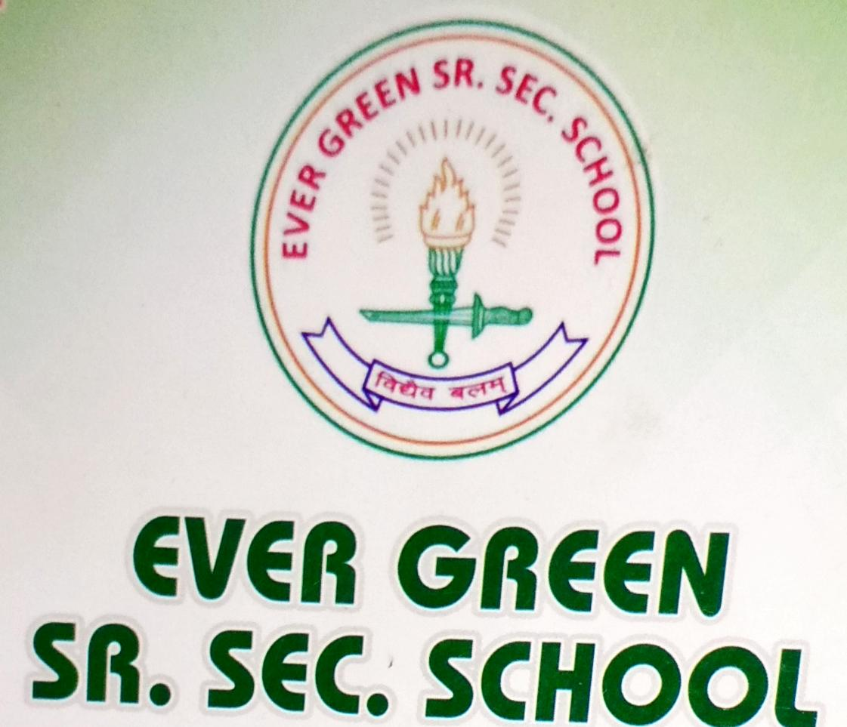

Certificate
This is so certify that the project affiliate “cloud computing” bring the submitting to Ever green sr
Sec. School , haldwani for the project week of information technology is a record of week carried by miss Naina singh under the guidance and supervisor.

Date : supervisor
. MR praveen joshi ICT evergreen sr sec school
Haldwani

Formatted by
Mr MS parwal
Principal
Ever green sr sec school

Acknowledgement
I would like to express my most sincer heartfelt gratitude and respect to my supervisor mr praveen joshi for suggesting the topic of my project work for his excellence guidance valuable suggestions and endless support Throughout the preparing for report I am gently instead to for his constructive suggestions....
TOPIC- Smart card
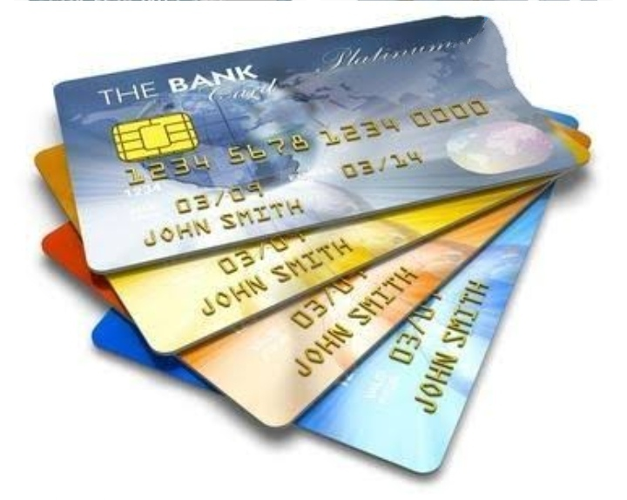
What is smart card
A smart card is a physical card that has an embedded integrated chip(Assembly of electric component)That acts as a security token smart card are normally the same size as a driver’s license or credit and debit card these can be made out of metal or plastic out of metal or plastic..
- The smart card invented by kunitaka Armours In Japan filled the first and only patent on the smart card concept in 1974.....
- Rolando Moreno Aufranc filled make origonal copy of card is called smart card....
Types of cards
The smart card have two different type of interface
SMART CARD
(i)contect card
(ii) contactless card
CONTECT CARD :Contact smart card are inserted into a smart card reader making physical contact with the reader this is the most common type of smart card electrical contact located on the outside of card.
CONTECTLESS CARD: these cards have an antenna embedded inside the card that enable communication with the reader without physical contact.these contactless card are using radio, frequency means (RF) technology to interact with a reader.each card has an Tina embedded inside the card that enables.......
- Example of smart cards
Smart card Application and include
- PAYMENT Card
- DEBIT Cards
- CREDIT Cards
- PAYMENT card:Payment card is a part of Paymentm system issued by financial institution,Such as a bank to customer that enable its owner such as a bank or customer that enable a
Its owner (the card holder) To access the fund in the customer's designated Bank account or through a credit account or through a credit account of maker payment by electronic fund transfer and access automatedteller.....
DEBIT Card : A debit card is a plastic card we use as payment method instead of cash when we buy things we also call it a bank card or check card.A debit card debit your bank account ; hence the name a purchaser's card may carry a stored value......
CREDIT Card: A credit card is a thin rectangular piece of plastic or metal card issued by financial institution it allows somebody to get a good services without using money you usually receive a bill once a month for what you have bought and lets her borrow funds from a pre-approved limited to pay for you purchases the limit is decided by the institution issuing the card based on your credit score and history.....
- How many types of smart cards in India?
- Fixed file structure
- Dynamic application system
The Fixed file structure formate datalayer enable retrieval data form A text file in which the value occupy a certain number of characters and are not otherwise delimited.........
To use the data layer you must define the recorder layout using a define the recorder layout using a fixed record layout element element And one or more data filed element.
- Dynamic data driven application system :dynamic data driven application system (DDDAS) is a new parking whereby the The computation and the instrumentation integrated in a feedback control loop in the sense that instrumentation data can be dynamically Incorporated into the executing module of the application.........

. . Thank you

